Walkthrough 17 Fragment Callbacks

https://sapui5.hana.ondemand.com/#/topic/354f98ed2b514ba9960556333428d35e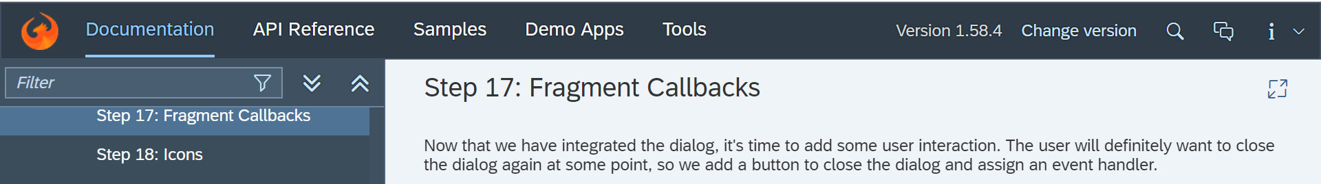

Core Changed Codes Compared to Last Version:

HelloDialog.fragment.xml【Update】

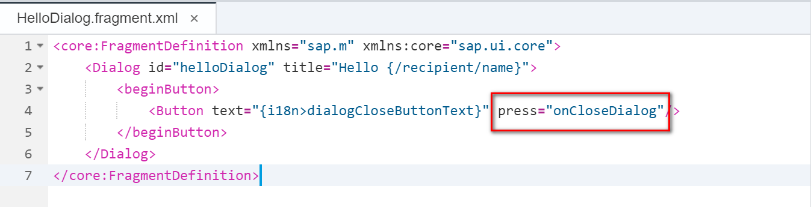

HelloPanel.controller.js【Update】

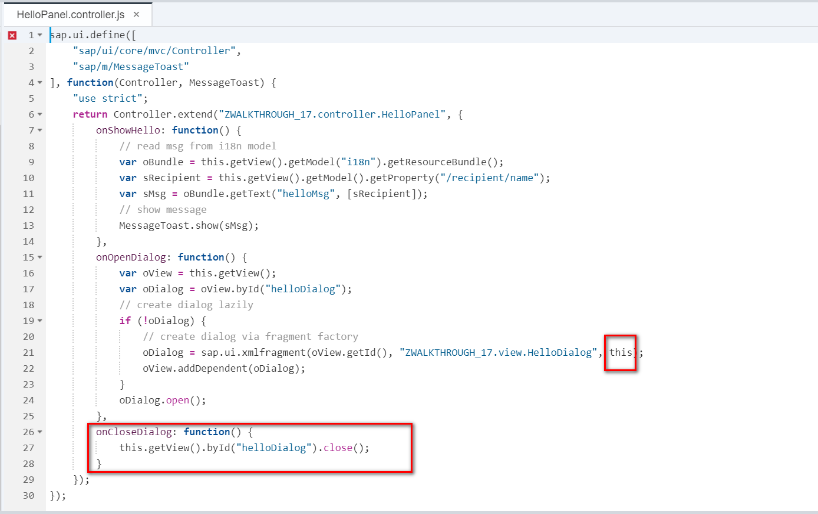

I18n【Update】

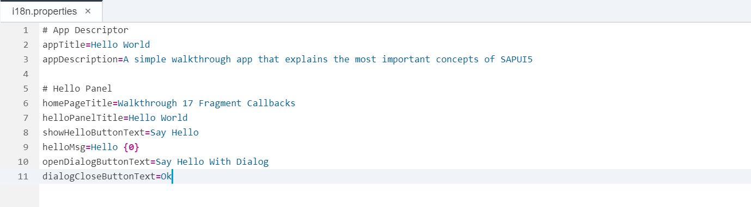

Result:

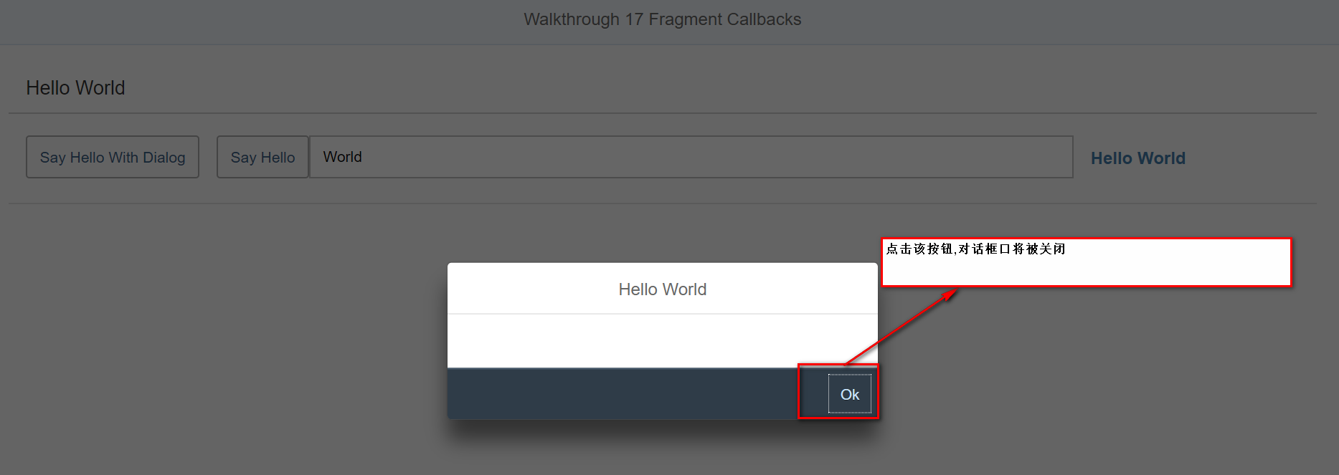

Git:

https://github.com/xiexiaop/SAPUI5-2-Round/tree/master/Projects/ZWALKTHROUGH_17

2018/11/09 XiaoMi Beijing Zac,Xie